**What is Clustering?**

Clustering is dividing data points into homogeneous classes or clusters:

* Points in the same group are as similar as possible
* Points in different group are as dissimilar as possible

When a collection of objects is given, we put objects into group based on similarity.

**Application of Clustering:**

Clustering is used in almost all the fields. You can infer some ideas from Example 1 to come up with lot of clustering applications that you would have come across.

Listed here are few more applications, which would add to what you have learnt.

* Clustering helps marketers improve their customer base and work on the target areas. It helps group people (according to different criteria’s such as willingness, purchasing power etc.) based on their similarity in many ways related to the product under consideration.
* Clustering helps in identification of groups of houses on the basis of their value, type and geographical locations.
* Clustering is used to study earth-quake. Based on the areas hit by an earthquake in a region, clustering can help analyse the next probable location where earthquake can occur.

**Clustering Algorithms:**

A Clustering Algorithm tries to analyse natural groups of data on the basis of some similarity. It locates the centroid of the group of data points. To carry out effective clustering, the algorithm evaluates the distance between each point from the centroid of the cluster.

The goal of clustering is to determine the intrinsic grouping in a set of unlabelled data.

**What is K-Means Algorithm?**

K-Means Clustering is an [Unsupervised Learning algorithm](https://www.javatpoint.com/unsupervised-machine-learning), which groups the unlabeled dataset into different clusters. Here K defines the number of pre-defined clusters that need to be created in the process, as if K=2, there will be two clusters, and for K=3, there will be three clusters, and so on.

It is an iterative algorithm that divides the unlabeled dataset into k different clusters in such a way that each dataset belongs only one group that has similar properties.

It allows us to cluster the data into different groups and a convenient way to discover the categories of groups in the unlabeled dataset on its own without the need for any training.

It is a centroid-based algorithm, where each cluster is associated with a centroid. The main aim of this algorithm is to minimize the sum of distances between the data point and their corresponding clusters.History of Java

The algorithm takes the unlabeled dataset as input, divides the dataset into k-number of clusters, and repeats the process until it does not find the best clusters. The value of k should be predetermined in this algorithm.

The k-means [clustering](https://www.javatpoint.com/clustering-in-machine-learning) algorithm mainly performs two tasks:

* Determines the best value for K center points or centroids by an iterative process.
* Assigns each data point to its closest k-center. Those data points which are near to the particular k-center, create a cluster.

Hence each cluster has data points with some commonalities, and it is away from other clusters.

The below diagram explains the working of the K-means Clustering Algorithm:

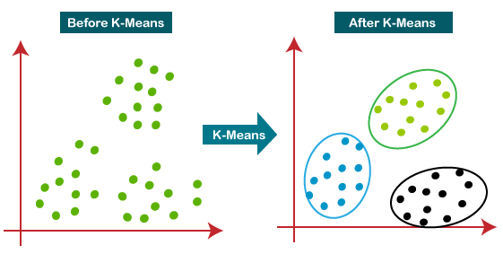

How does the K-Means Algorithm Work?

The working of the K-Means algorithm is explained in the below steps:

**Step-1:** Select the number K to decide the number of clusters.

**Step-2:** Select random K points or centroids. (It can be other from the input dataset).

**Step-3:** Assign each data point to their closest centroid, which will form the predefined K clusters.

**Step-4:** Calculate the variance and place a new centroid of each cluster.

**Step-5:** Repeat the third steps, which means reassign each datapoint to the new closest centroid of each cluster.

**Step-6:** If any reassignment occurs, then go to step-4 else go to FINISH.

**Step-7**: The model is ready.

Let's understand the above steps by considering the visual plots:

Suppose we have two variables M1 and M2. The x-y axis scatter plot of these two variables is given below:

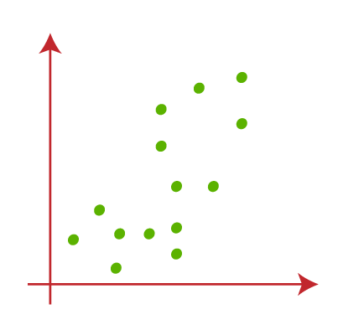

Let's take number K of clusters, i.e., K=2, to identify the dataset and to put them into different clusters. It means here we will try to group these datasets into two different clusters.

We need to choose some random k points or centroid to form the cluster. **These points can be either the points from the dataset or any other point**. So, here we are selecting the below two points as k points, which are not the part of our dataset.

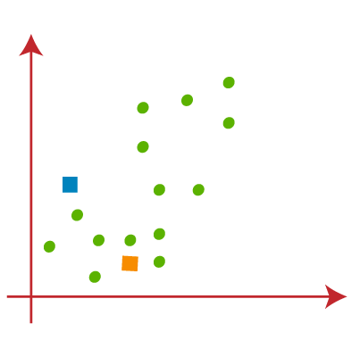

Now we will assign each data point of the scatter plot to its closest K-point or centroid. We will compute it by applying some mathematics that we have studied to calculate the distance between two points. So, we will draw a median between both the centroids.

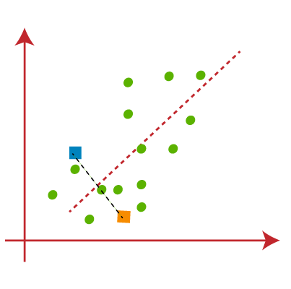

From the above image, it is clear that points left side of the line is near to the K1 or blue centroid, and points to the right of the line are close to the yellow centroid. Let's color them as blue and orange for clear visualization.

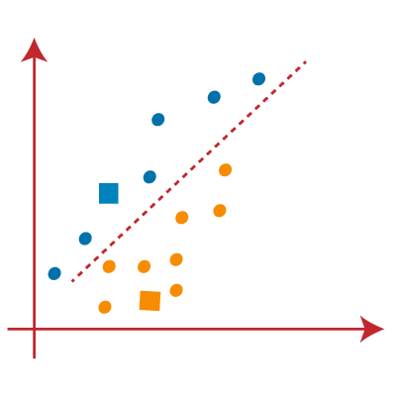

As we need to find the closest cluster, so we will repeat the process by choosing **a new centroid**. To choose the new centroids, we will compute the center of gravity of these centroids, and will find new centroids as below:

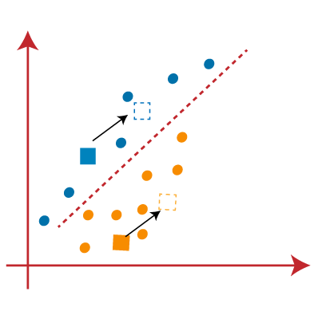

Next, we will reassign each data point to the new centroid. For this, we will repeat the same process of finding a median line. The median will be like below image:

* 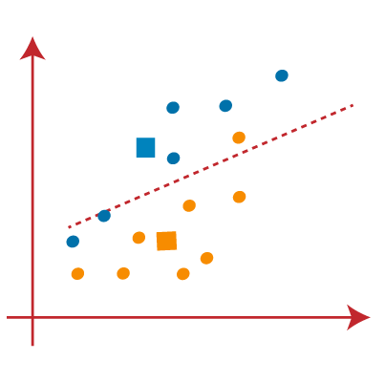

From the above image, we can see, one yellow point is on the left side of the line, and two blue points are right to the line. So, these three points will be assigned to new centroids.

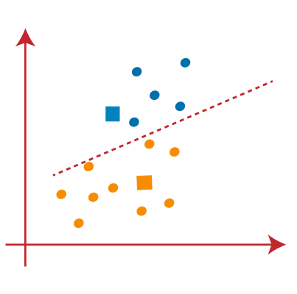

As reassignment has taken place, so we will again go to the step-4, which is finding new centroids or K-points.

We will repeat the process by finding the center of gravity of centroids, so the new centroids will be as shown in the below image:

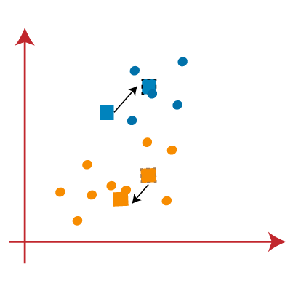

As we got the new centroids so again will draw the median line and reassign the data points. So, the image will be:

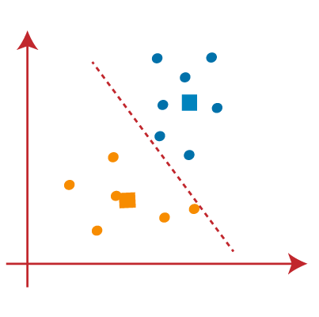

We can see in the above image; there are no dissimilar data points on either side of the line, which means our model is formed. Consider the below image:

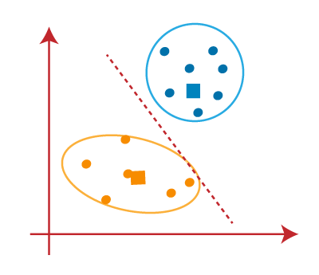

As our model is ready, so we can now remove the assumed centroids, and the two final clusters will be as shown in the below image:

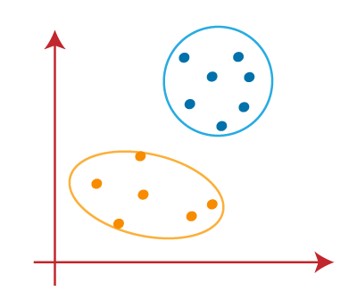

## How to choose the value of "K number of clusters" in K-means Clustering?

The performance of the K-means clustering algorithm depends upon highly efficient clusters that it forms. But choosing the optimal number of clusters is a big task. There are some different ways to find the optimal number of clusters, but here we are discussing the most appropriate method to find the number of clusters or value of K. The method is given below:

### Elbow Method

The Elbow method is one of the most popular ways to find the optimal number of clusters. This method uses the concept of WCSS value. **WCSS** stands for **Within Cluster Sum of Squares**, which defines the total variations within a cluster. The formula to calculate the value of WCSS (for 3 clusters) is given below:

**WCSS= ∑Pi in Cluster1 distance(Pi C1)2 +∑Pi in Cluster2distance(Pi C2)2+∑Pi in CLuster3 distance(Pi C3)2**

In the above formula of WCSS,

**∑Pi in Cluster1** distance(Pi C1)2: It is the sum of the square of the distances between each data point and its centroid within a cluster1 and the same for the other two terms.

To measure the distance between data points and centroid, we can use any method such as Euclidean distance or Manhattan distance.

To find the optimal value of clusters, the elbow method follows the below steps:

* It executes the K-means clustering on a given dataset for different K values (ranges from 1-10).
* For each value of K, calculates the WCSS value.
* Plots a curve between calculated WCSS values and the number of clusters K.
* The sharp point of bend or a point of the plot looks like an arm, then that point is considered as the best value of K.

Since the graph shows the sharp bend, which looks like an elbow, hence it is known as the elbow method. The graph for the elbow method looks like the below image:

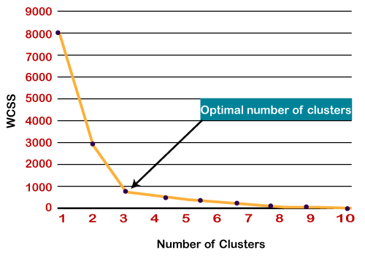

## ****Mathematical Formulation for K-means Algorithm:****

D= {**x1,x2,…,xi,…,xm**} à data set of m records

**xi**= **(xi1,xi2,…,xin)** à each record is an n-dimensional vector

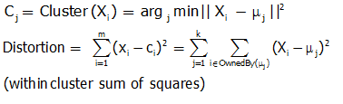

## ****Finding Cluster Centers that Minimize Distortion:****

Solution can be found by setting the partial derivative of Distortion w.r.t. each cluster center to zero.

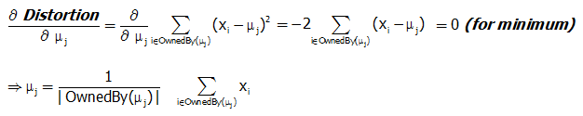

For any k clusters, the value of k should be such that even if we increase the value of k from after several levels of clustering the distortion remains constant. The achieved point is called the “Elbow”.

### Silhouette Method:

The**silhouette Method**is also a method to find the optimal number of clusters and interpretation and validation of consistency within clusters of data. The silhouette method computes silhouette coefficients of each point that measure how much a point is similar to its own cluster compared to other clusters.

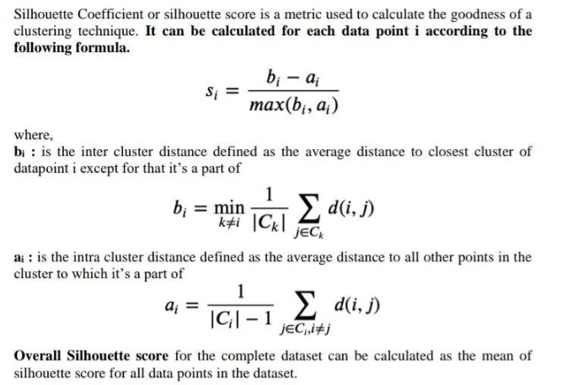

Silhouette analysis can be used to study the separation distance between the resulting clusters. The silhouette plot displays a measure of how close each point in one cluster is to points in the neighbouring clusters and thus provides a way to assess parameters like number of clusters visually. This measure has a range of [-1, 1].

Silhouette coefficients (as these values are referred to as) near +1 indicate that the sample is far away from the neighbouring clusters. A value of 0 indicates that the sample is on or very close to the decision boundary between two neighbouring clusters and negative values indicate that those samples might have been assigned to the wrong cluster.

In this example the silhouette analysis is used to choose an optimal value for n_clusters. The silhouette plot shows that the n_clusters value of 3, 5 and 6 are a bad pick for the given data due to the presence of clusters with below average silhouette scores and also due to wide fluctuations in the size of the silhouette plots. Silhouette analysis is more ambivalent in deciding between 2 and 4.

Also from the thickness of the silhouette plot the cluster size can be visualized. The silhouette plot for cluster 0 when n_clusters is equal to 2, is bigger in size owing to the grouping of the 3 sub clusters into one big cluster. However when the n_clusters is equal to 4, all the plots are more or less of similar thickness and hence are of similar sizes as can be also verified from the labelled scatter plot on the right.

